**Lab 5**

Alec Wood

SDEV 300: Building Secure Python Applications

November 22nd, 2021

|  |  |  |  |  |
| --- | --- | --- | --- | --- |
| Test Case | Input | Expected | Actual | Pass/Fail |
| Test 1 | Population  Change Pop | Change pop graph | Change pop graph | Pass |
| Test 2 | Housing  Rooms | Rooms graph | Rooms graph | Pass |
| Test 3 | Exit | Program break | Program break | Pass |

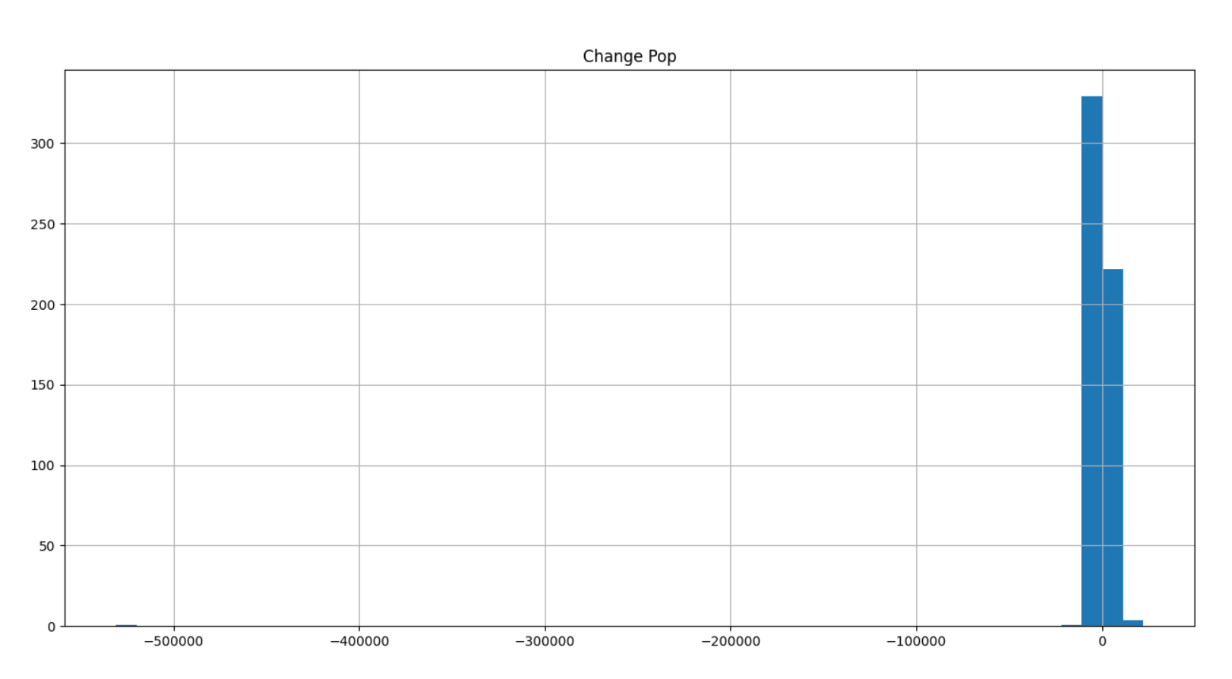

Test 1

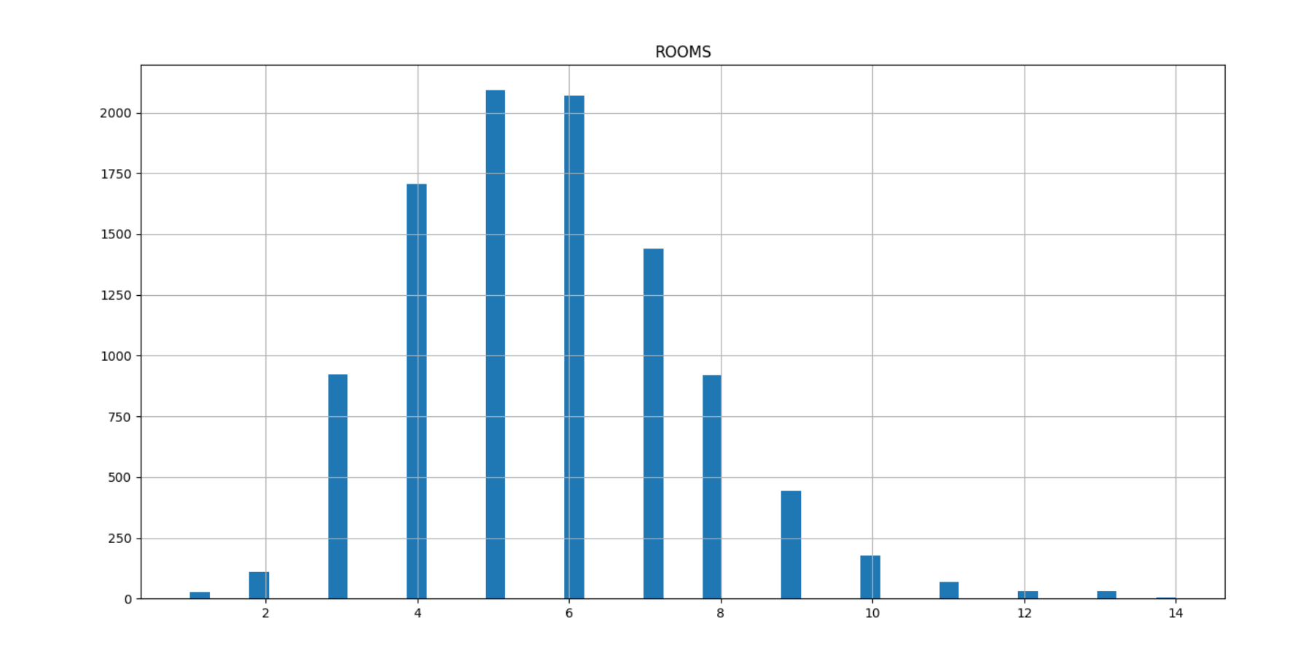

Test 2

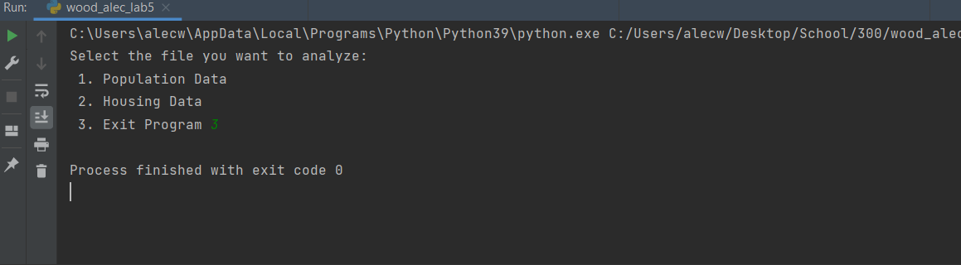

Test 3

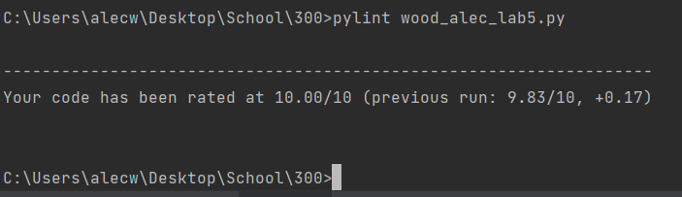

Pylint 10.00 score